Question 1

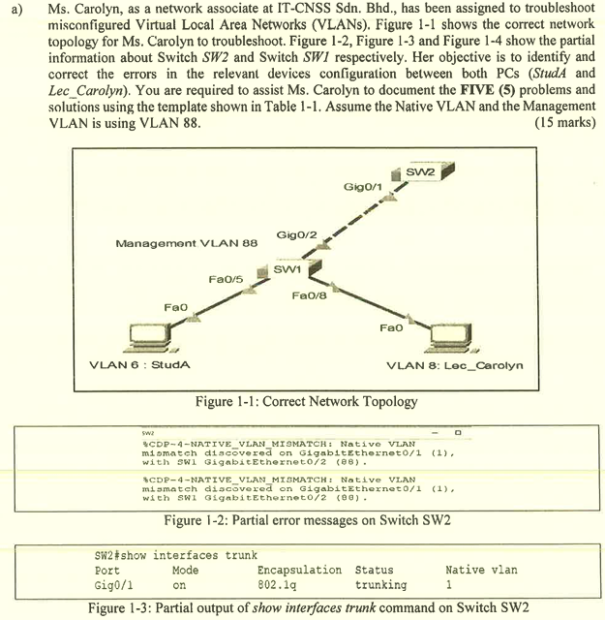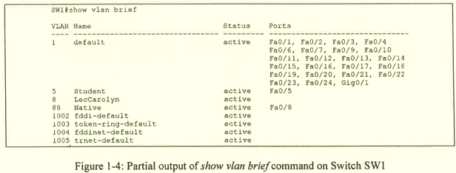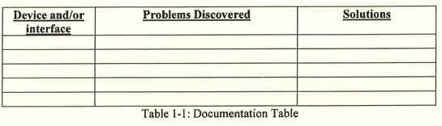
Device and/or interface | Problems Discovered | Solutions
SW2 | The interface Gig0/1 native vlan is wrongly configured. | Assign VLAN 88 to the interface Gig0/1.  interface Gig0/1  switchport trunk native vlan 88
SW1 | Native vlan is not assigned to trunk linport Gig0/2 | Assign VLAN 88 to interface Gig0/2.  interface Gig0/2  switchport trunk native vlan 88
SW1 | The Student VLAN is using the wrong VLAN number. | Configure Student VLAN with vlan number 6.  no vlan 5  vlan 6  name Student
SW1 | The VLAN assigned to interface Fa0/5 is incorrect. | Assign VLAN 6 to interface Fa0/5.  interface Fa0/5  switchport mode access  switchport access vlan 6  no shutdown
SW1 | The VLAN assigned to interface Fa0/8 is incorrect. | Assign VLAN 8 to interface Fa0/8.  interface Fa0/8  switchport mode access  switchport access vlan 8  no shutdown

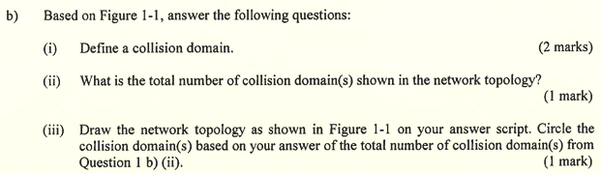
(i) One or more devices are running in half-duplex mode which can lead to contention in bandwidth.

(ii) 3 collision domains

(iii)
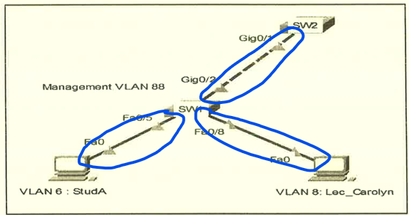

- Store-and-forward switching
  - It receives the entire frame and ensures that the frame is valid.
  - It will check the Frame Check Sequence (FCS) for CRC error.
  - The ingress interface will buffer the frame when checking FCS, to allow the switch to adjust potential difference in speed between ingress and egress interface.
  - It may take longer to forward the frame.
- Cut-through switching
  - It immediately forwards the frame when determining the destination MAC address and egress port.
  - It does not check Frame Check Sequence (FCS).
  - It does not support ports with differing speeds from ingress to egress.
  - The fragment free method will check whether the frame size has at least 64 bytes for eliminating runts.
  - It has low latency within 10 microseconds.

Question 2

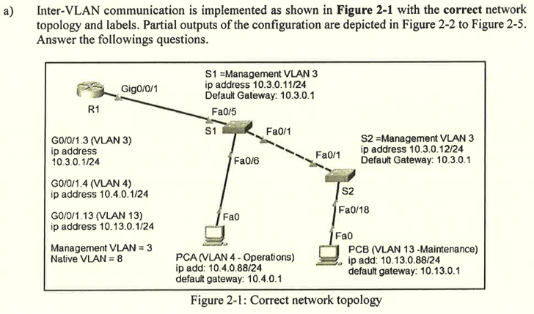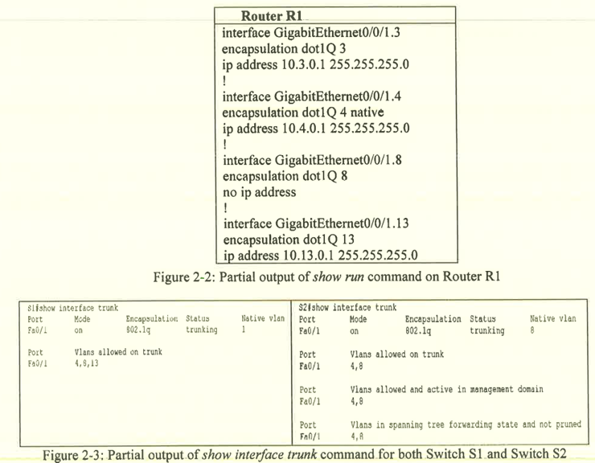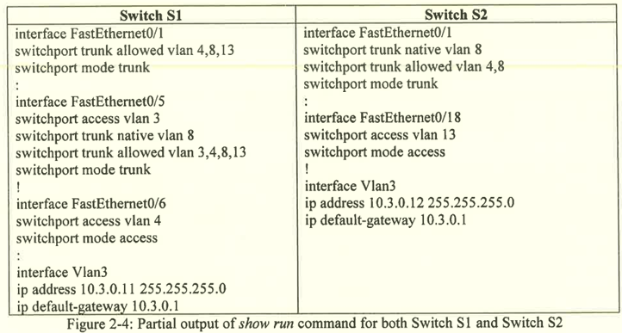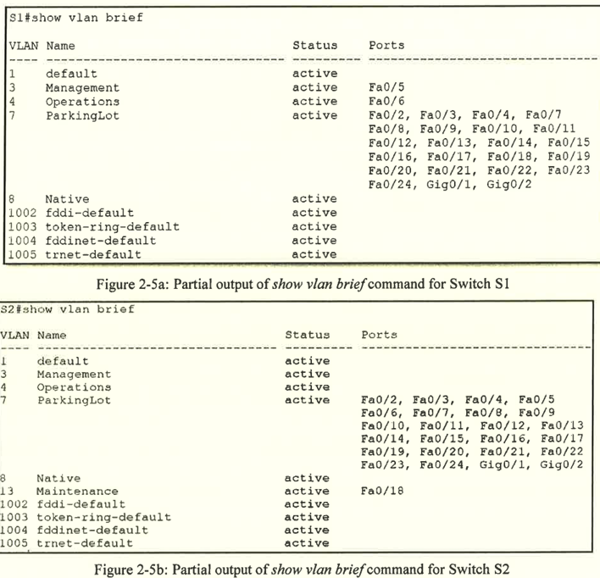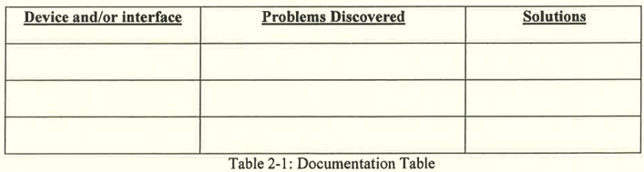
Device and/or interface | Problems Discovered | Solutions
Router R1 | The native vlan should not be assigned to VLAN 4. | The native vlan should be assigned to vlan 8 in GigabitEthernet0/0/1.8  interface GigabitEthernet0/0/1.4  no encapsulation dot1Q 4 native  encapsulation dot1Q 4  ip address 10.4.0.1 255.255.255.0  interface GigabitEthernet0/0/1.8  encapsulation dot1Q 8 native
Switch S1 | The native vlan assigned to Fa0/1 is wrong. | The native vlan 8 should be assigned to Fa0/1.  interface Fa0/1  switchport trunk native vlan 8
Switch S2 | The vlans allowed on the interface Fa0/1 trunk is wrongly configured. | Only vlan 3, 8 and 13 should be allowed on Fa0/1 trunk port.  interface Fa0/1  switchport trunk allowed vlan 3,8,13
Switch S1 | The interface FastEthernet0/5 should not be configured in access mode. | The interface FastEthernet0/5 should be configured in trunk mode.  interface f0/5  switchport mode trunk  switchport trunk allowed vlan 3,4,8,13  switchport trunk native vlan 8
Switch S1 | The interface Fa0/5 is not configured as trunk port. | The interface Fa0/5 should be configured in trunk mode.  interface Fa0/5  switchport mode trunk  switchport trunk allowed vlan 3,4,8,13  switchport trunk native vlan 8
Switch S1 | Interface Vlan3 is not used. | The interface Vlan3 should be removed.  no interface Vlan3
Switch S2 | Interface Vlan3 is not used. | The interface Vlan3 should be removed.  no interface Vlan3

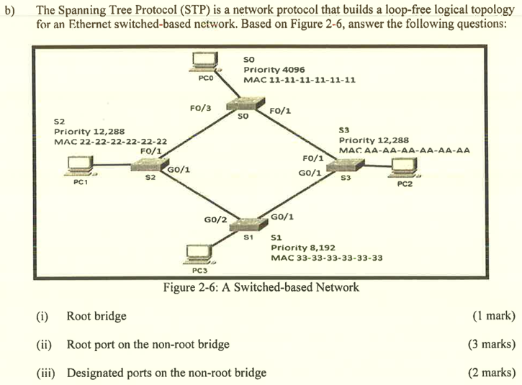
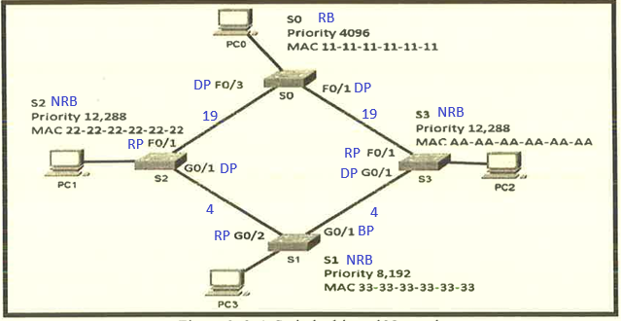
(i) S0

(ii)
- S1: G0/2
- S2: F0/1
- S3: F0/1

(iii)
- S0: F0/1, F0/3
- S2: G0/1
- S3: G0/1

Question 3

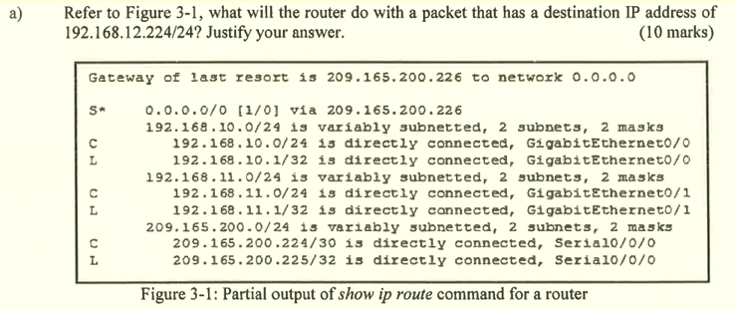
- Router will check whether the destination IP address 192.168.12.224 of the packet matches any directly connected network route in the routing table.
- Since there is no matching route, the router will check whether the destination IP address matches any remote network route in the routing table.
- Since there is no matching remote network route, the router will check whether there is the gateway of last resort to handle the situation when the destination IP address of packet does not belong to any available route in the routing table.
- Since there is a default route of 0.0.0.0/0 marked as 'S*', the router will encapsulate the packet and forward it to the next hop address 209.165.200.226.

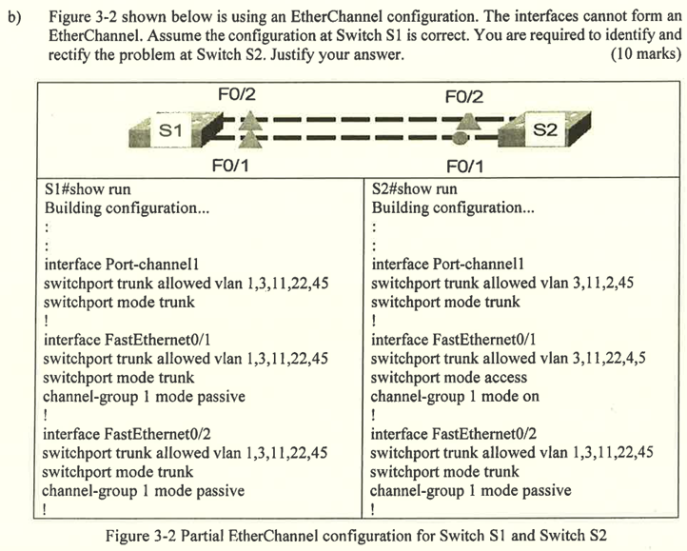
- Allowed vlan on port-channel 1 is configured wrong.
  - VLAN 1, 3, 11, 22 and 45 should be allowed on the port-channel 1.
interface port-channel1
switchport trunk allowed 1,3,11,22,45
- Allowed vlan on FastEthernet0/1 is configured wrong.
  - VLAN 1, 3, 11, 22 and 45 should be allowed on the FastEthernet0/1.
interface FastEthernet0/1
switchport trunk allowed vlan 1,3,11,22,45
- Switchport mode on FastEthernet0/1 is configured wrong.
  - Switchport mode should be set into trunk mode.
interface FastEthernet0/1
switchport mode trunk
- Etherchannel mode on FastEthernet0/1 is wrongly configured.
  - Etherchannel mode should be set into active mode.
interface FastEthernet0/1
no channel-group 1 mode on
channel-group 1 mode active
- Etherchannel mode on FastEthernet0/2 is wrongly configured.
  - Etherchannel mode should be set into active mode.
interface FastEthernet0/2
no channel-group 1 mode on
channel-group 1 mode active

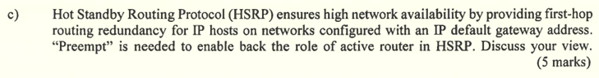
- The preempt feature can help in triggering the HSRP re-election process when a new router comes online.
- When the new router with higher HSRP priority comes online, the re-election process will be triggered and elect the new router to become the active router.
- Meanwhile, the previous active router will be elected as standby router.

Question 4

Address Resolution Protocol (ARP) Attack
- Hosts broadcasts ARP requests for obtaining MAC address of other hosts and the destination IP address.
- Attackers will send gratuitous ARP message to switch with spoofed MAC address to cause the switch to update the MAC table accordingly.
- Attackers will send unsolicited ARP replies to host with IP address of threat actor and default gateway IP address, setting up man-in-the-middle attack.

Spanning Tree Protocol (STP) Attack
- Attackers will attack and manipulate the Spanning Tree Protocol by spoofing the root bridge and changing the network topology.
- Attackers will capture all traffic in the immediate switched domain.
- Attackers' host will then broadcast a STP Bridge Protocol Data Unit (BPDU) to AP with configuration and topology changes for triggering spanning tree recalculation.
- The BPDU sent by the attackers' host will announce a lower bridge priority for being elected as active router.

- Wireless client will listen to the channel if it is idle.
- It will send Ready to Send (RTS) message to AP for dedicated access to network.
- It receives a Clear to Send (CTS) message from AP granting access to network.
- It waits random period of time before restarting the process if does not receive any CTS message.
- It will transmit data.
- It will acknowledge all transmission. If no CTS message received, it will be considered as collision occurred. So, it will restart the process.

- Authentication
- Authorization
- Accounting

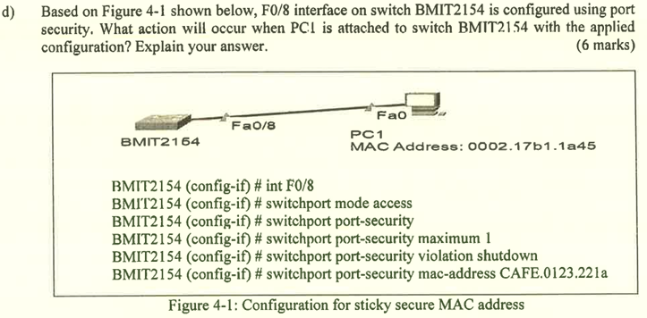
- PC1 can only send 1 packet to switch BMIT2154 per second.
- If an exceeds the number of packets sent to the switch in one second, the port Fa0/8 will be immediately put into error-disabled state.
- When this situation happens, the switch will generate a syslog message, increment the violation counter by 1 and turn off the port LED.
- The administrator needs to manually turn back the port using command shutdown and no shutdown.
- The MAC address CAFE.0123.221a is "stuck" to the running configuration of the switch BMIT2154. So, the switch will always remember this MAC address even after being restarted.

